
A PBL REPORT ON
“To develop a social media website”
Submitted to
INFORMATION TECHNOLOGY, BHARATI VIDYAPEETH (DEEMED TO BE
UNIVERSITY) COLLEGE OF ENGINEERING, PUNE

In Partial Fulfilment of the Requirement for the Award of

BACHELOR’S DEGREE IN
INFORMATION TECHNOLOGY
BY

NAME | PRN | Seat No.
Shreshtha Raj | 2214110262 | 2422930543
Apurva Thakur | 2214110264 | 2422930544
Avinash Pathak | 2214110258 | 2422930575

UNDER THE GUIDANCE OF
Prof. T.B.Patil

DEPARTMENT OF INFORMATION TECHNOLOGY
BHARATI VIDYAPEETH (DEEMED TO BE UNIVERSITY)
COLLEGE OF ENGINEERING, PUNE, INDIA - 411043
2023-2024


CERTIFICATE
This is to certify that the project entitled
“To develop a social media website”
Submitted by :-

Apurva Thakur 2214110264
Shreshtha Raj 2214110262
Avinash Pathak 2214110258

is a record of bona fide work carried out by them, in the partial fulfilment of requirement for the award of Degree of Bachelor of Technology in Information Technology at Bharati Vidyapeeth (Deemed to Be University) College of Engineering, Pune, India. This work is done during academic year 2023-2024.

Date: / /
Sign

(Prof. T.B Patil)
(Pbl Guide)

ACKNOWLEDGEMENT

We would like to express deepest appreciation towards Dr Vidula Sohoni, Principal, Bharati Vidyapeeth (Deemed to Be University) College of Engineering, Pune and Dr Sandeep Vanjale, Head of Department of IT, who invaluably supported us in completing this project.
We are profoundly grateful to Prof. T.B.Patil , Project guide for his expert guidance and continuous encouragement throughout to see that this project right, its target since its commencement to its completion.
At last, we must express our sincere heartfelt gratitude to all the staff members of IT Department who helped us directly or indirectly during this course of work.

INDEX

No. | TOPIC | Page
1. | Introduction | 5
2. | What is Social media? | 5
3. | It’s Business applications | 5
4. | What are the benefits of social media? | 6
5. | What are the challenges of social media? | 8
6. | Role of ITM | 10
7. | Future Trends and Innovations in social media | 12
8. | Elements required to create a social media website | 14
9. | Code | 16
10. | Output | 21

Introduction

What is Social media?
Social media refers to online platforms and websites that enable users to create, share, and exchange content and information with others. These platforms typically allow users to communicate, collaborate, and interact with each other in various ways, such as posting text, images, videos, and links, as well as commenting, liking, sharing, and messaging. Social media platforms may include popular sites like Facebook, Twitter, Instagram, LinkedIn, Snapchat, TikTok, and many others. They have become integral parts of modern communication, allowing individuals, businesses, organizations, and communities to connect, engage, and share ideas, news, and experiences across the globe. Social media has enormous traction globally. Mobile applications make these platforms easily accessible. Some popular examples of general social media platforms include Twitter, Facebook and LinkedIn.

Business applications of Social Media :-

In business, social media is used to market products, promote brands, connect to customers and foster new business. As a communication platform, social media promotes customer feedback and makes it easy for customers to share their experiences with a company. Businesses can respond quickly to positive and negative feedback, address customer problems and maintain or rebuild customer confidence.
Social media is also used for crowdsourcing. That's the practice of using social networking to gather knowledge, goods or services. Companies use crowdsourcing to get ideas from employees, customers and the general public for improving products or developing future products or services.

What are the benefits of social media?

User visibility : Social platforms let people easily communicate and exchange ideas or content.
Business and product marketing : These platforms enable businesses to quickly publicize their products and services to a broad audience. Businesses can also use social media to maintain a following and test new markets. In some cases, the content created on social media is the product.
Audience building : Social media helps entrepreneurs and artists build an audience for their work. In some cases, social media has eliminated the need for a distributor, because anyone can upload their content and transact business online.

Connectivity: Social media platforms enable people to connect with friends, family, colleagues, and acquaintances regardless of geographical barriers. It facilitates communication and fosters relationships by providing instant messaging, video calls, and sharing of updates and photos.

Information Sharing: Social media serves as a vast source of information on various topics, including news, current events, trends, and educational content. Users can access a wealth of information shared by individuals, organizations, and media outlets, helping them stay informed and engaged.

Networking: Social media platforms offer opportunities for professional networking and career advancement. Users can connect with professionals in their industry, join relevant groups and communities, and engage in discussions to expand their professional network and access new opportunities.

Promotion and Marketing: Businesses can leverage social media for promotion and marketing purposes. They can create profiles on popular platforms, share content, interact with customers, and run targeted advertising campaigns to reach a larger audience, increase brand visibility, and drive sales.

Customer Engagement: Social media provides a platform for businesses to engage with their customers directly. Companies can respond to inquiries, address concerns, and gather feedback in real-time, fostering better relationships with customers and improving customer satisfaction.

Brand Building: Social media allows businesses to build and strengthen their brand identity. They can share their values, mission, and culture through engaging content, storytelling, and visual elements, helping to differentiate themselves from competitors and create a positive brand image.

Community Building: Social media enables the formation of communities and online forums where people with similar interests or goals can come together to share ideas, support each other, and collaborate on projects. These communities provide a sense of belonging and can be valuable sources of knowledge and inspiration.

Educational Resources: Social media platforms offer access to a wide range of educational resources, including tutorials, webinars, and online courses. Users can learn new skills, acquire knowledge, and stay updated on industry developments through curated content shared by experts and educators.

Awareness and Activism: Social media has become a powerful tool for raising awareness about social issues, promoting causes, and mobilizing support for various campaigns and movements. Activists and advocacy groups can use social media to amplify their message, organize events, and drive social change.

Creativity and Self-Expression: Social media platforms provide users with creative outlets for self-expression, allowing them to share their thoughts, ideas, and creations with the world. Users can express themselves through written posts, photos, videos, art, music, and other forms of content, fostering creativity and personal growth.

What are the challenges of social media?

While social media offers numerous benefits, it also presents several challenges, including:

1. Privacy Concerns: Social media platforms collect vast amounts of user data, raising concerns about privacy and data security. Users may unknowingly share personal information, leading to privacy breaches, identity theft, and targeted advertising. Additionally, data privacy regulations such as GDPR and CCPA impose compliance challenges for social media companies.

2. Cyberbullying and Harassment: Social media can be a breeding ground for cyberbullying, harassment, and online abuse. Users may experience harassment, trolling, and hate speech, leading to psychological distress and negative mental health outcomes. Social media companies face challenges in combating abusive behavior and maintaining a safe online environment for users.

3. Fake News and Misinformation: Social media facilitates the rapid spread of misinformation, rumors, and fake news. False information can go viral quickly, leading to confusion, distrust, and societal harm. Social media companies struggle to identify and mitigate the spread of misinformation while balancing concerns over censorship and free speech.

4. Algorithmic Bias: Social media algorithms can perpetuate bias and discrimination, resulting in unequal treatment and limited exposure for certain groups. Algorithmic biases in content recommendation, advertising targeting, and news feed algorithms can reinforce stereotypes, exacerbate societal divisions, and marginalize underrepresented communities.

5. Addiction and Mental Health Issues: Excessive use of social media has been linked to addiction, anxiety, depression, and other mental health problems. The constant need for validation, comparison with others, and fear of missing out (FOMO) can contribute to feelings of inadequacy and low self-esteem. Social media companies face criticism for designing platforms that prioritize user engagement over well-being.

6. Echo Chambers and Polarization: Social media algorithms tend to reinforce users' existing beliefs and preferences, creating echo chambers and filter bubbles. This can lead to ideological polarization, tribalism, and reduced exposure to diverse perspectives. Users may become isolated within their echo chambers, limiting their ability to engage in constructive dialogue and critical thinking.

7.Online Radicalization and Extremism: Social media platforms have been used to spread extremist ideologies, recruit followers, and organize acts of violence. Online radicalization poses significant challenges for social media companies, law enforcement agencies, and policymakers in detecting and countering extremist content while preserving freedom of speech.

8.Impact on Relationships: Excessive use of social media can strain real-life relationships and interpersonal interactions. Users may prioritize online connections over face-to-face communication, leading to feelings of loneliness, isolation, and disconnection from the offline world. Social media companies face criticism for their role in shaping social dynamics and interpersonal relationships.

Addressing these challenges requires collaboration among social media companies, policymakers, educators, mental health professionals, and users themselves to promote responsible use, safeguard privacy and security, combat online abuse and misinformation, and foster a healthier digital environment.

Role of ITM

Social media can be a valuable tool for information technology (IT) management, offering opportunities to communicate with stakeholders, showcase expertise, and stay updated on industry trends. Here are some strategies for leveraging social media effectively in IT management:

1.Establish a Strong Presence: Create profiles on relevant social media platforms such as LinkedIn, Twitter, and GitHub to showcase your company's expertise, projects, and thought leadership in the IT field.

2.Share Valuable Content: Share informative and engaging content related to IT topics such as software development, cybersecurity, cloud computing, and data analytics. This could include blog posts, whitepapers, case studies, infographics, and videos.

3.Engage with the Community: Join industry groups, forums, and discussions on social media platforms to connect with other IT professionals, share insights, and participate in conversations. Engage with your audience by responding to comments, answering questions, and providing helpful resources.

4.Demonstrate Thought Leadership: Position yourself and your company as thought leaders in the IT industry by sharing your expertise, insights, and opinions on emerging technologies, industry trends, and best practices. Publish articles, participate in webinars, and speak at conferences to showcase your knowledge and experience.

5.Highlight Success Stories: Share success stories and case studies highlighting your company's IT projects, innovations, and achievements. Showcase how your solutions have helped clients solve problems, improve efficiency, and achieve their goals.

6.Promote Events and Webinars: Use social media to promote IT-related events, webinars, workshops, and training sessions hosted by your company. Encourage followers to register, participate, and engage with the content.

7.Provide Customer Support: Use social media as a channel for providing customer support and assistance with IT-related inquiries, issues, and technical problems. Respond promptly to customer queries and complaints to enhance satisfaction and build trust.

8.Monitor Industry Trends: Stay updated on the latest trends, news, and developments in the IT industry by following relevant hashtags, influencers, and industry publications on social media. Use social listening tools to monitor conversations and identify emerging topics and opportunities.

9.Collaborate with Influencers: Partner with influencers, bloggers, and industry experts in the IT field to amplify your message, reach new audiences, and build credibility. Collaborate on content creation, guest blogging, or co-hosting webinars and events.

10.Measure and Analyze Performance: Track key performance metrics such as engagement, reach, and conversions to evaluate the effectiveness of your social media efforts. Use analytics tools to gain insights into audience demographics, preferences, and behavior, and adjust your strategy accordingly.

By implementing these strategies, IT managers can leverage social media to strengthen their company's brand, build relationships with stakeholders, and stay ahead in the rapidly evolving field of information technology.

Future Trends and Innovations in social media:

Predicting future trends and innovations in social media is always challenging due to the fast-paced nature of technological advancements and shifting user behaviors. However, several potential trends and innovations can be anticipated based on current developments and emerging technologies:

1. Augmented Reality (AR) and Virtual Reality (VR): AR and VR technologies are likely to play a significant role in the future of social media, enabling users to experience immersive and interactive content. Social media platforms may incorporate AR filters, lenses, and effects for enhanced storytelling and engagement, while VR experiences could facilitate virtual meetups, events, and shared experiences.

2. AI-Powered Personalization: Artificial intelligence (AI) will continue to drive personalized content recommendations, targeted advertising, and user experiences on social media platforms. AI algorithms will analyze user data and behavior to deliver tailored content, products, and services, enhancing user engagement and satisfaction.

3. Short-form Video Content: Short-form video content, popularized by platforms like TikTok and Instagram Reels, is expected to remain a dominant trend in social media. More platforms may introduce features for creating and sharing short videos, encouraging creativity, spontaneity, and viral trends among users.

4. Audio-First Platforms: The rise of audio-first social media platforms, exemplified by Clubhouse and Twitter Spaces, indicates a growing interest in voice-based communication and content. Future innovations may include features for live audio discussions, podcasts, and voice-based interactions within social networks.

5. Ephemeral Content: Ephemeral content, such as Stories on Snapchat, Instagram, and Facebook, continues to gain popularity due to its temporary and authentic nature. Social media platforms may introduce new formats and features for ephemeral content, driving user engagement and FOMO (fear of missing out).

6. Blockchain and Cryptocurrency Integration: Blockchain technology and cryptocurrencies could revolutionize social media by enabling decentralized networks, secure transactions, and new forms of digital ownership. Blockchain-based social media platforms may prioritize user privacy, data ownership, and content monetization.

7. Niche Communities and Micro-Communities: Users are increasingly seeking niche communities and micro-communities centered around specific interests, hobbies, and identities. Social media platforms may introduce features for creating and joining specialized groups, fostering deeper connections and meaningful interactions among like-minded individuals.

8. Social Commerce and Shoppable Content: Social commerce is expected to continue growing, with more social media platforms integrating shopping features, product tagging, and checkout options directly into the user experience. Brands and influencers will leverage social media as a primary channel for driving sales and conversions.

9. Ethical Design and Digital Well-being: Social media platforms may prioritize ethical design principles and digital well-being features to address concerns about addiction, mental health, and online safety. Features such as time management tools, content moderation, and user controls may be enhanced to promote healthier usage habits.

10.Cross-platform Integration: Social media platforms may increasingly integrate with each other and with external services, enabling seamless cross-platform experiences and data interoperability. Users may have the option to share content, messages, and activities across multiple platforms, streamlining their online presence and interactions.

While these trends and innovations offer exciting opportunities for the future of social media, it's essential to consider the potential challenges and implications, such as privacy concerns, algorithmic biases, and regulatory scrutiny. Social media companies will need to balance innovation with responsibility, prioritizing user trust, safety, and well-being in their product development efforts.

Elements required to create a social media website :

Creating a social media website requires careful planning, design, and development to ensure it meets the needs of users and provides a seamless and engaging experience. Below are the key elements required to create a social media website:

1. Concept and Purpose: Define the concept and purpose of your social media website. Determine the target audience, niche, and unique selling proposition (USP) that differentiate your platform from others.

2. Feature Set: Identify the core features and functionalities your social media website will offer. Common features include user profiles, news feeds, posting/sharing content, liking/commenting, messaging, notifications, search functionality, groups/communities, events, and user settings/preferences.

3. User Registration and Authentication: Implement a user registration system that allows users to create accounts and authenticate their identity securely. Include options for email verification, password management, and social login integration (e.g., using Facebook, Google).

4. User Profiles: Develop user profile pages where users can personalize their profiles with photos, bio information, contact details, and privacy settings. Allow users to customize their profiles and control who can view their information.

5. News Feed and Content Publishing: Design a news feed or timeline where users can view posts, updates, and content from people and pages they follow. Implement features for creating and publishing various types of content, including text posts, photos, videos, links, and polls.

6. Social Interactions: Enable social interactions such as likes, comments, shares, and reactions on posts and content. Implement real-time updates and notifications to keep users engaged and informed about activity within their network.

7. Messaging and Communication: Integrate messaging and communication features to facilitate private and group conversations between users. Provide options for text messaging, voice/video calls, file sharing, and emoji reactions.

8. Community Building: Allow users to create and join groups, communities, or interest-based forums where they can connect with like-minded individuals, discuss topics of interest, and share relevant content. Implement features for group moderation, member management, and content curation.

9. Content Discovery and Search: Develop robust search functionality that enables users to discover relevant content, people, groups, and topics within the social media platform. Implement filters, sorting options, and personalized recommendations to enhance the content discovery experience.

10. Privacy and Security: Prioritize user privacy and security by implementing robust data protection measures, encryption protocols, and privacy settings. Provide users with granular control over their privacy preferences, visibility settings, and data sharing permissions.

11. Mobile Responsiveness: Ensure your social media website is optimized for mobile devices and responsive across different screen sizes and resolutions. Design a mobile-friendly user interface and prioritize performance optimization for fast loading times and smooth navigation.

12. Analytics and Insights: Integrate analytics and reporting tools to track user engagement, behaviour patterns, and performance metrics. Provide administrators with insights into user activity, content performance, demographic trends, and growth opportunities.

13. Monetization Options: Consider various monetization strategies for generating revenue from your social media website, such as advertising, sponsored content, premium subscriptions, in-app purchases, and affiliate marketing. Implement monetization features while maintaining a positive user experience and minimizing intrusiveness.

14. Scalability and Maintenance: Build your social media website on a scalable and maintainable architecture that can accommodate growth in user base and traffic over time. Plan for regular updates, bug fixes, security patches, and server maintenance to ensure the platform remains reliable and secure.

By incorporating these elements into your social media website, you can create a dynamic and engaging platform that attracts users, fosters community engagement, and provides value to its members. Additionally, consider conducting user testing and gathering feedback throughout the development process to iteratively improve the user experience and meet the evolving needs of your audience.

Code :-

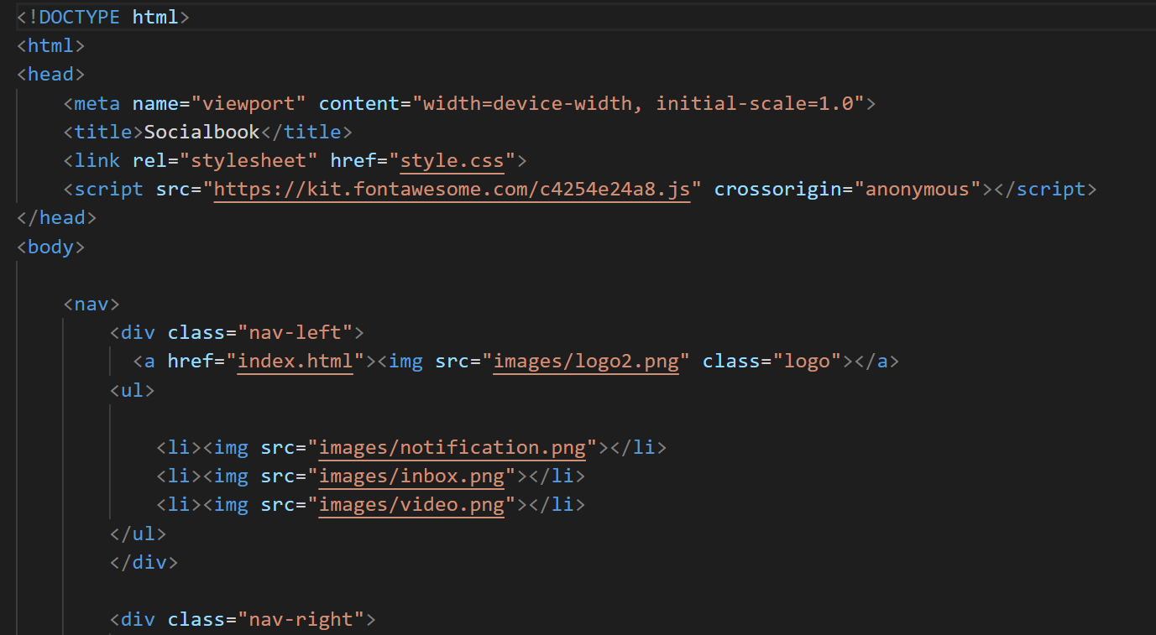
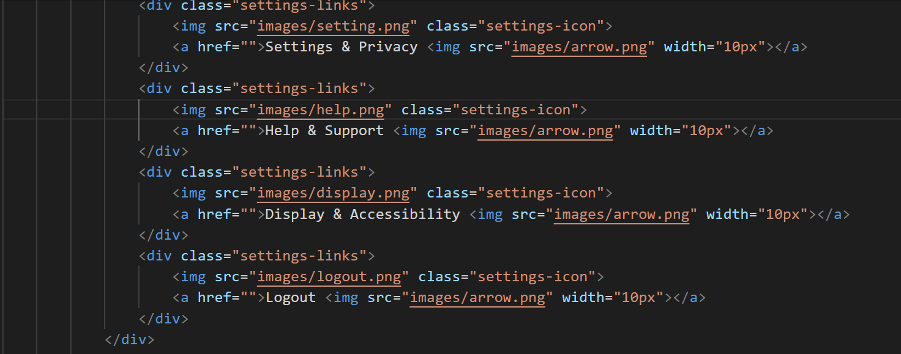
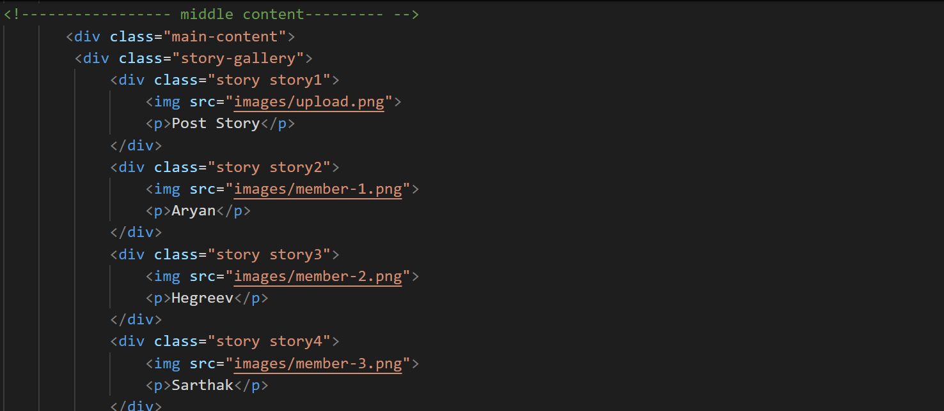

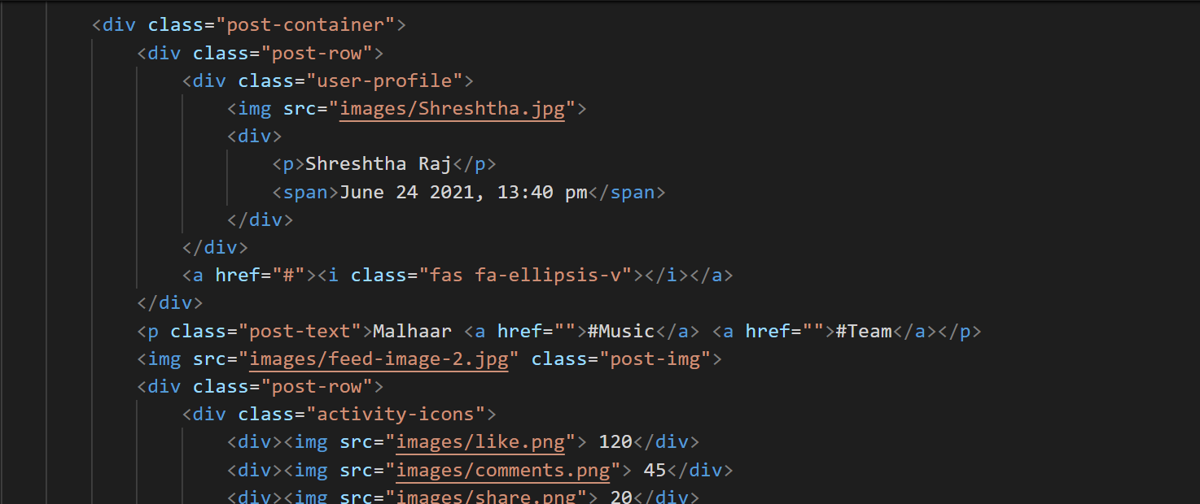

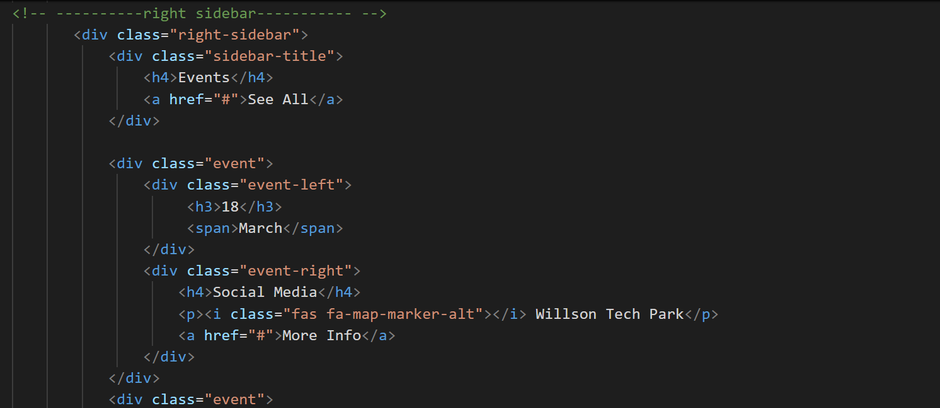

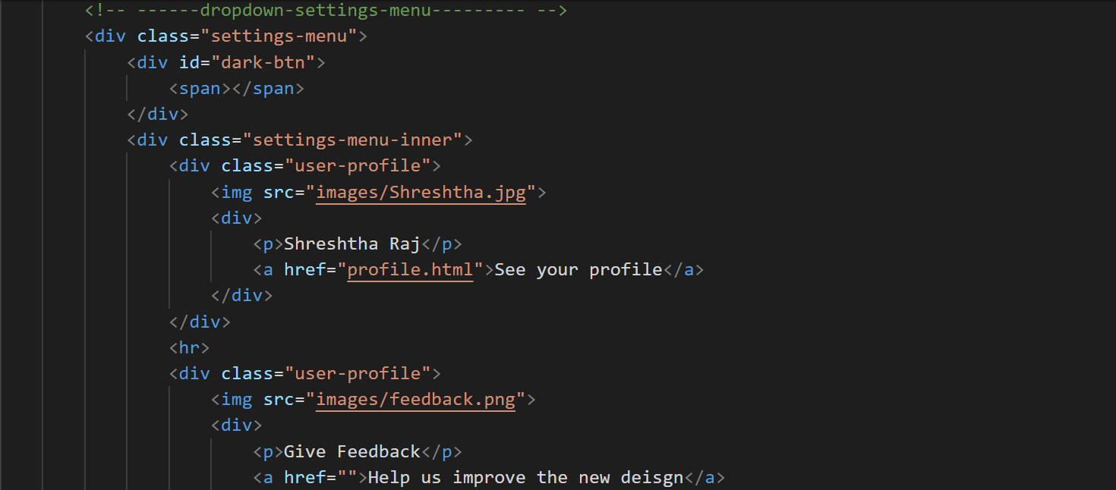

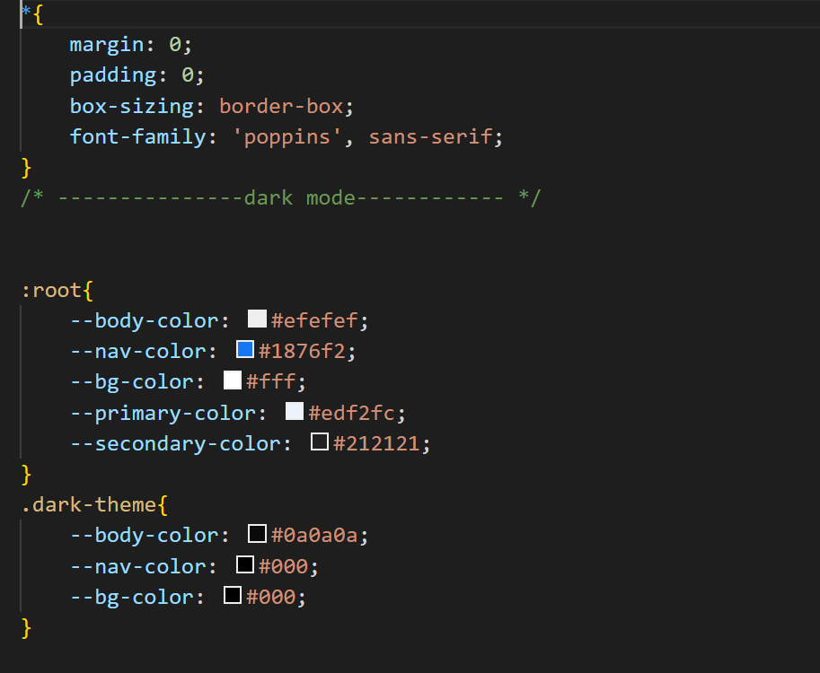

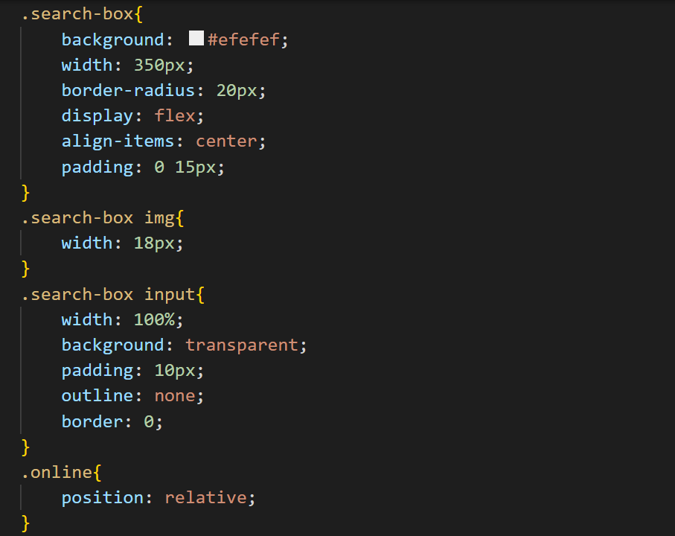

Output :-

